جامعة تكريت
السیاسیة كلية العلوم
Headway Beginners
مدرس المادة م م علي خلف عبدالله

Definite and Indefinite Articles (a, an, the)

I. Introduction (5 minutes)
Good morning, everyone! Today, we are going to talk about Articles in English. Articles are small words, but they are very important because they come before nouns. They help us to say whether we are talking about something general or something specific.
In English, there are two types of articles:
1. Indefinite Articles: a, an
2. Definite Article: the

II. Indefinite Articles (a, an) (10 minutes)
We use 'a' before a word that begins with a consonant sound. For example: a book, a car, a teacher.
We use 'an' before a word that begins with a vowel sound (a, e, i, o, u). For example: an apple, an engineer, an hour (note: 'h' is silent here).
We use 'a' and 'an' when we talk about something for the first time or when it is not specific.
Example: I saw a man in the park yesterday. (We don’t know which man – it is general).

III. Definite Article (the) (10 minutes)
We use 'the' when we talk about something specific or something already known to the speaker and the listener.
Example: The sun is hot. (There is only one sun).
Example: I saw a dog. The dog was brown. (Now we know which dog).
We also use 'the' with unique things: the Earth, the sky, the president.

IV. Board Illustration
Here is a simple chart that shows how to use articles:

V. Practice & Q&A (10 minutes)
Let’s try some examples tog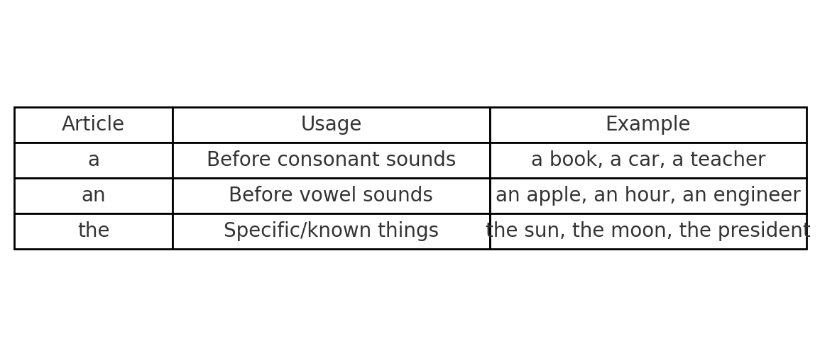ether! Fill in the blanks with 'a', 'an', or 'the'.
1. I bought __ apple yesterday. (an)
2. She is reading __ interesting book. (an)
3. __ moon looks beautiful tonight. (The)
4. He is __ doctor. (a)
Any questions about articles?

